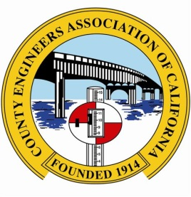
County Engineers Association of California
LEGISLATIVE PROPOSAL ACTION REQUEST FORM
Please return this form by COB Wednesday, August 7, 2024

For your proposal to be considered, please respond to all questions included in this form. Proposals must be submitted to CEAC through your Public Works Director or Department Head. Please submit this form to Merrin Gerety at mgerety@counties.org

Proposals will be referred to the appropriate policy committees and considered during the 2024 CEAC Policy Conference, August 22-23, 2024.

Contact Name:
County:
Position:
Phone:
Email:

Brief Description of Legislative Proposal:

I. BACKGROUND INFORMATION

A. Problem

- What problem does the proposal address? Please share specific facts and examples to illustrate the problem.
- Does the proposal address a problem of statewide significance? Give specific facts and examples, which demonstrate a statewide need for the proposal.
- Have counties been involved in any litigation regarding this problem? If so, cite the case.
- What other source materials, case law, or data, document the existence of the problem (e.g., periodicals, government agency reports, private studies, law review articles, newspaper articles)?

B. Interested Parties

(1) What counties, organizations or individuals are interested in the problem?
(2) What counties, organizations or individuals would be sources of information about the problem?
(3) Who would be likely to support/oppose the proposal? Why?
(4) Identify groups or other governmental agencies that could be affected by the proposal, either favorably or adversely? Please Discuss.

II. PROPOSAL

A. Existing Law

(1) What are the statutory provisions currently applicable to the proposal?
(2) What case law is relevant to this issue? Please summarize and cite.
(3) Why is existing law inadequate to deal with the problem?

B. Suggested Legislation

(1) Describe the specific bill proposal.
(2) Do similar provisions exist in other California laws?
(3) Describe a hypothetical application of the proposal

C. Fiscal Impact

(1) Would there be any potential fiscal impact on counties under the proposal? If so, describe.
(2) Would there be any potential financial impact on other persons or organizations, public or private?

D. History

(1) Has this proposal ever been introduced in the Legislature? If so, what was the bill number and why did it fail?
(2) Is judicial or executive branch resolution of the problem possible? Explain.

E. Public Policy

(1) What are the public policy reasons in support of this proposal? Against?
(2) Would this proposal affect any related public policy? If so, describe.

